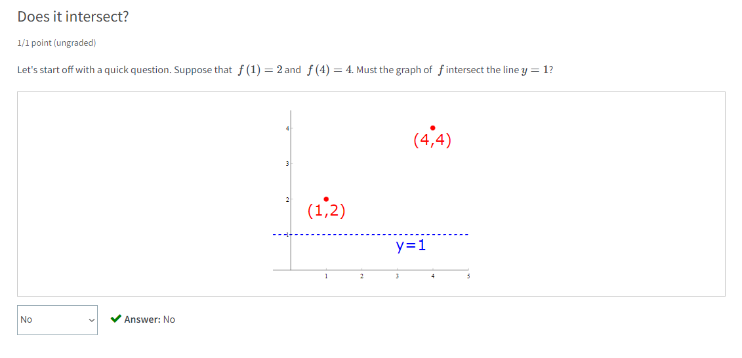

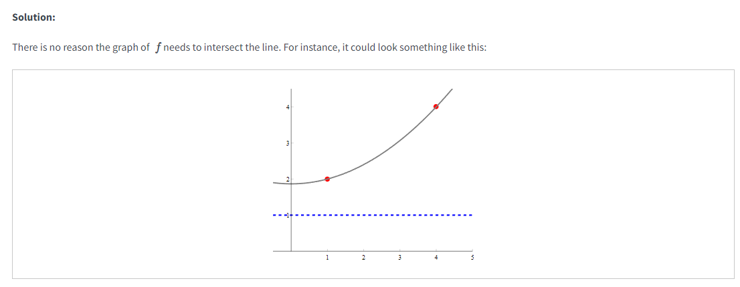

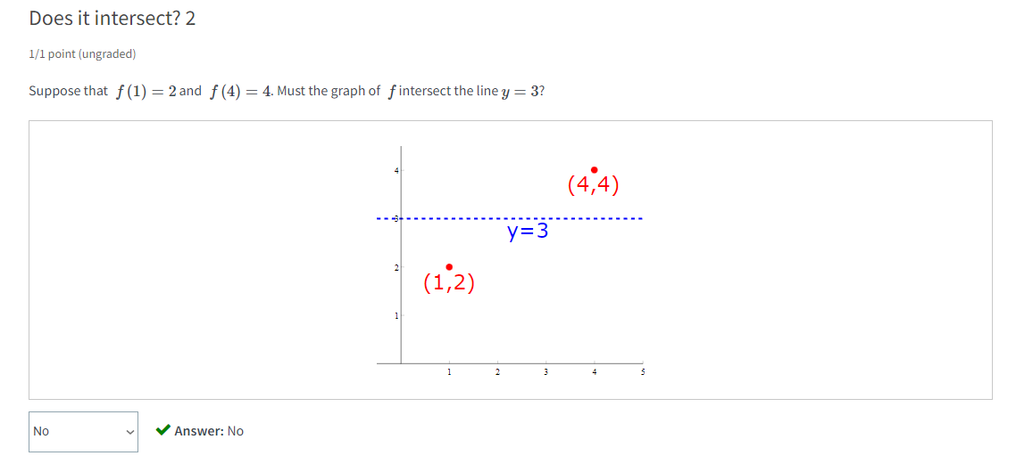

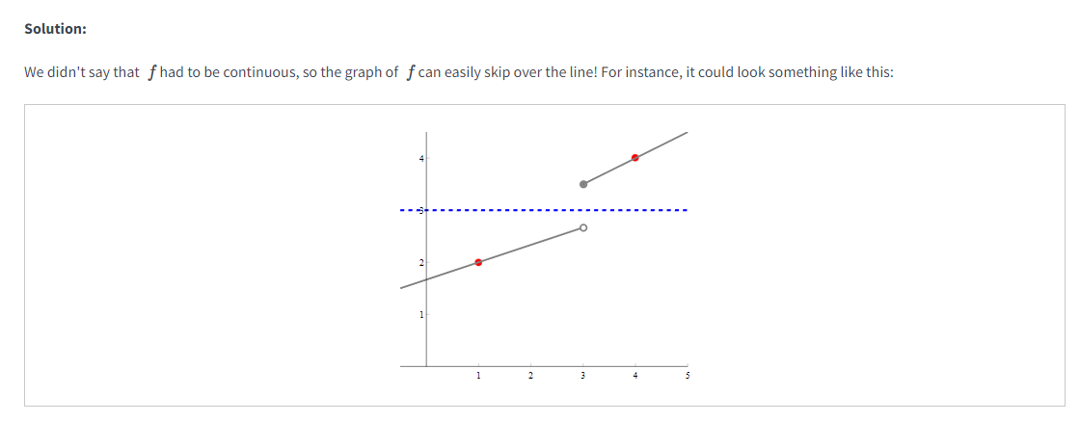

IVT (Intermediate Value Theorem)

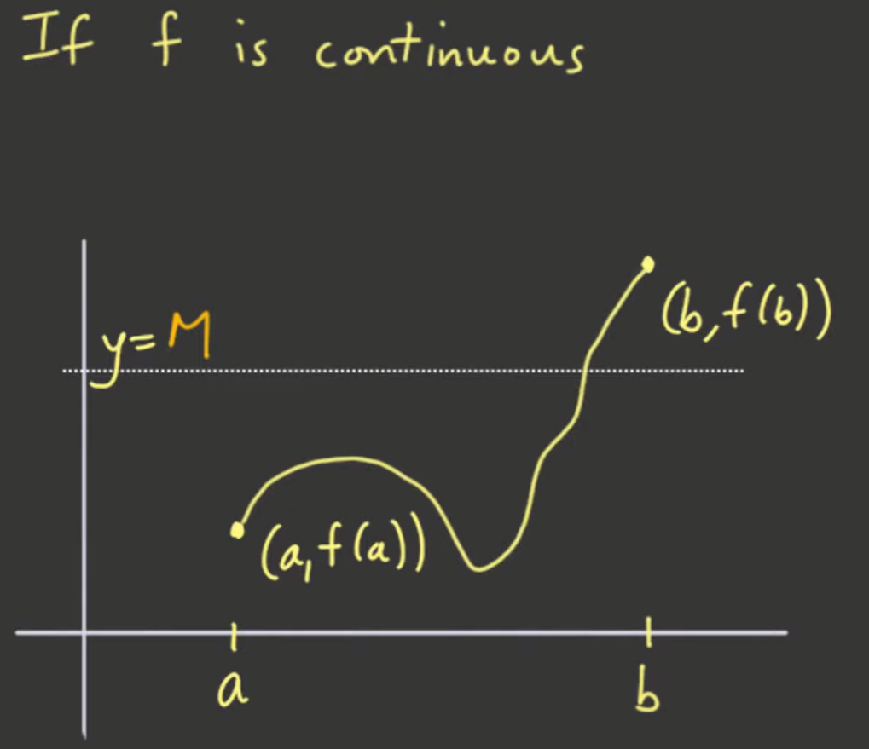

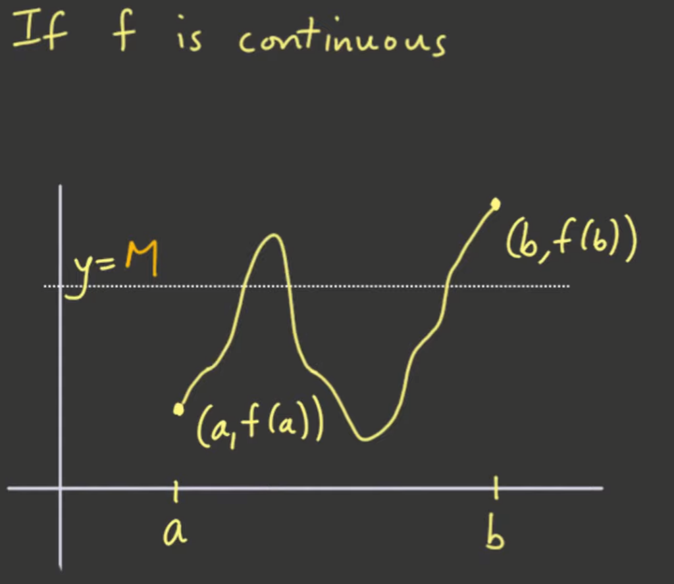

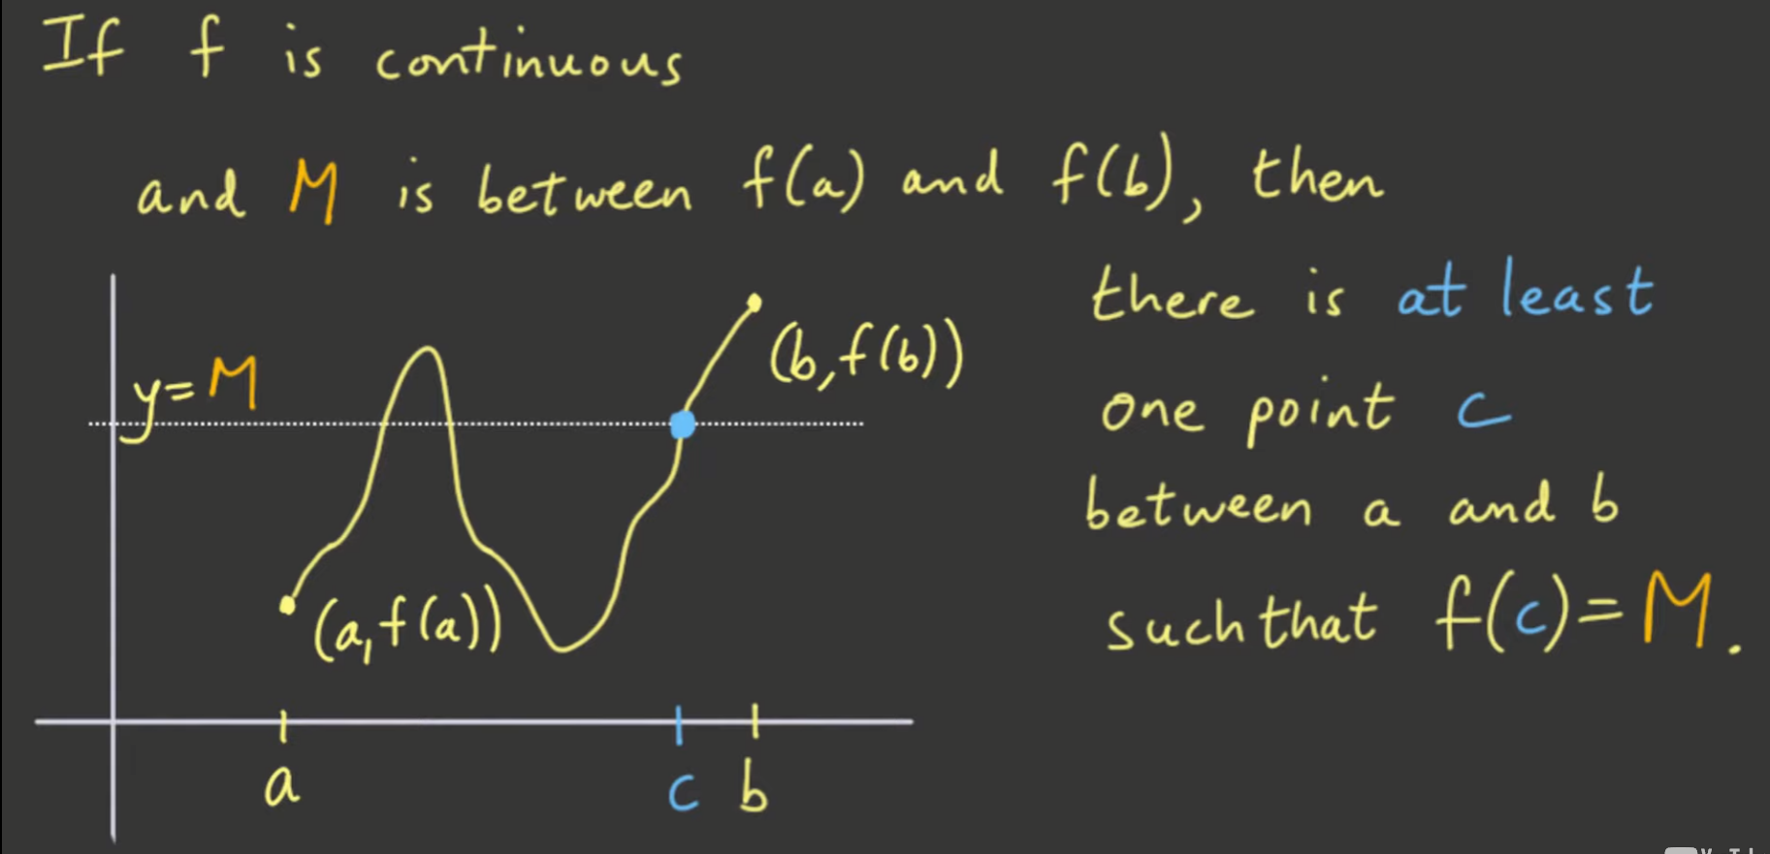

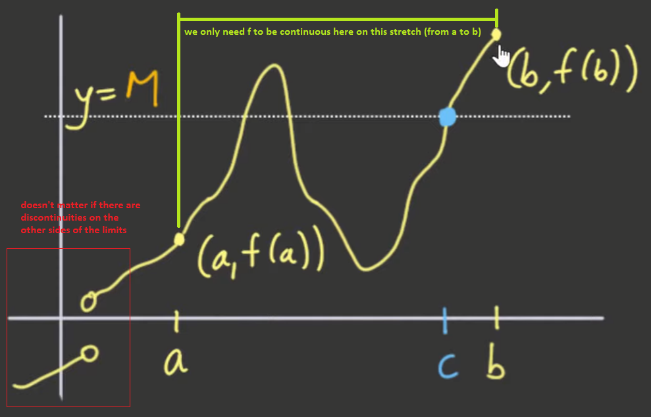

Final definition of Intermediate Value Theorem considering the continuity above:

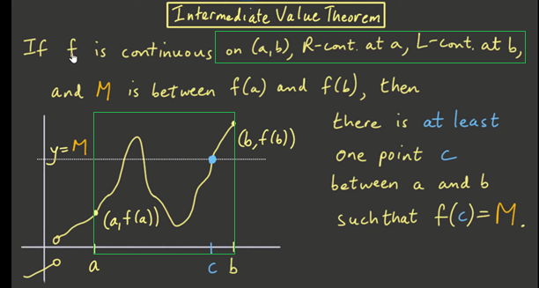





What makes the Intermediate Value Theorem a deep result?

The Intermediate Value Theorem is profound because it takes information that is local by nature, and allows you to conclude a global result. Continuity at a point is local information, because it only requires knowledge of the function's behavior near that point. But somehow, if we know this fact at every point on an interval, then the Intermediate Value Theorem tells us something about the overall, or global behavior - namely, that the function has to take on a particular value, or its graph has to cross a certain line.

This is intimately tied in with the properties of the real number system. We could have the same definition of continuity for functions if we only worked with, say, the rational numbers (numbers which can be written as a fraction of integers), but the Intermediate Value Theorem would not work if that were the case. It is only when we move to the real numbers that the Intermediate Value Theorem holds true.